This information is [freely available](https://gtr.ukri.org/) and can be downloaded from the UKRI website. All awarded grants can be searched (even those that have completed) using their database. It’s possible to filter for Research Grants and by funder (in this case BBSRC). However, it can be difficult to tell what is a Responsive Mode award compared to other types of grant. There is also a BBSRC-only database available [here](https://bbsrc.ukri.org/research/grants-search/advancedsearch/). On the BBSRC website, they make the recent awards available. I found these files easiest to use. They can be loaded into R and analysed.

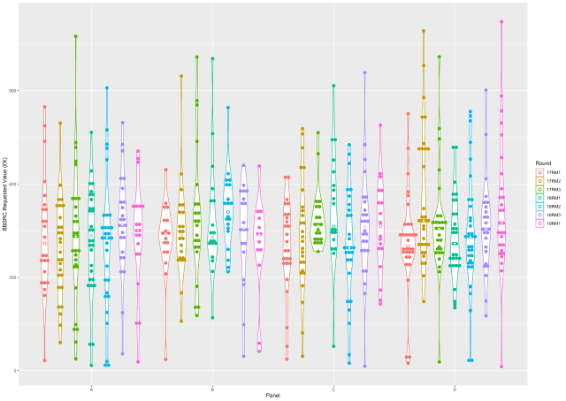

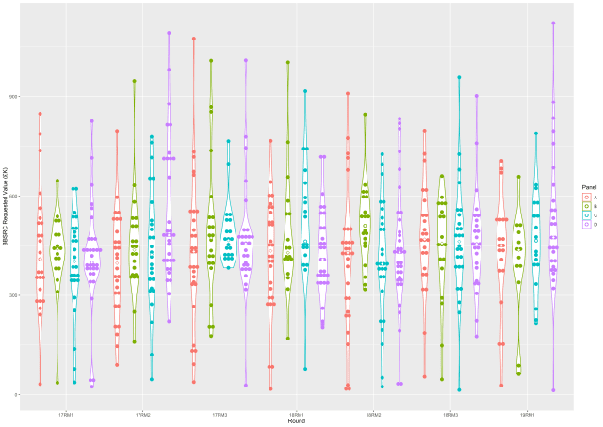

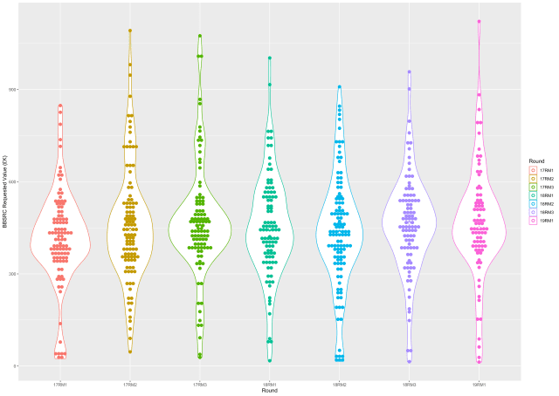

The BBSRC Requested Value is given in 1000s of GBP (£K). This value is the amount requested by the applicant. Given that the award is 80% of the full economic cost of the grant, then these figures should be multiplied by 1.25 to get the headline figure that applicants go in with.

There are three rounds per year and data is available from 2017 to the first round in 2019. A couple of things to note:

* The typical grant is around £500K, so this over £600K as the headline figure
* There are some very small awards. These are likely “child” awards linked to a parent application (usually at another University). They are difficult to remove and pull the median down.
* There are some very expensive grants. The guidelines say that you can apply for “up to £2M” but as you can see, the most expensive grant weighs in at £1.5M. Grants above £1M are very rare.
* Awards are pretty stable over the last few years and it doesn’t look like the median is creeping up (median is the open symbol at the centre of the violin).
* There’s always rumours that one committee’s grants tend to be more expensive. While the applications to committees may differ in value (no way of knowing from this dataset), the successful grants are pretty similar.

So the data-driven answer to the question above is that successful grants tend to be around £500K (requested value). This equates to one post-doc for three years with running costs, a few other items and then overheads.

Value for money can be taken into account by the committee when scoring the proposals so this is likely to affect expensive applications. In other words, the science proposed needs to be truly exceptional for a very expensive grant to be funded.

**Want to rerun this analysis?**

library(ggplot2)

df1 <- read.delim(file='BBSRCAwards.txt', header=TRUE, sep = '\t', stringsAsFactors=FALSE)

p1 <- ggplot(df1, aes(x=Round, y=ReqValue, colour=Round, fill=Round)) +

geom_violin(fill='white') +

geom_dotplot(binaxis='y', stackdir='center', position=position_dodge(0.9), binwidth=10) +

stat_summary(fun.y=median, geom="point", size=2, shape = 23, fill = "white", position=position_dodge(0.9)) +

labs(x = "Round", y = "BBSRC Requested Value (£K)")

p1

p2 <- ggplot(df1, aes(x=Round, y=ReqValue, colour=Panel, fill=Panel)) +

geom_violin(fill='white') +

geom_dotplot(binaxis='y', stackdir='center', position=position_dodge(0.9), binwidth=10) +

stat_summary(fun.y=median, geom="point", size=2, shape = 23, fill = "white", position=position_dodge(0.9)) +

labs(x = "Round", y = "BBSRC Requested Value (£K)")

p2

p3 <- ggplot(df1, aes(x=Panel, y=ReqValue, colour=Round, fill=Round)) +

geom_violin(fill='white') +

geom_dotplot(binaxis='y', stackdir='center', position=position_dodge(0.9), binwidth=10) +

stat_summary(fun.y=median, geom="point", size=2, shape = 23, fill = "white", position=position_dodge(0.9)) +

labs(x = "Panel", y = "BBSRC Requested Value (£K)")

p3

ggsave("ValueByRound.png", plot = p1)

ggsave("ValueByPanelAndRound.png", plot = p2)

ggsave("ValueByPanel.png", plot = p3)

The data is freely available [here](https://bbsrc.ukri.org/funding/post-application/awarded-grants/). I collated the available data into TSV format and added an extra column for the round.